Classifying data using Support Vector Machines(SVMs) in Python
Introduction to SVMs: In machine learning, support vector machines (SVMs, also support vector networks) are supervised learning models with associated learning algorithms that analyze data used for classification and regression analysis. A Support Vector Machine (SVM) is a discriminative classifier formally defined by a separating hyperplane. In other words, given labeled training data (supervised learning), the algorithm outputs an optimal hyperplane which categorizes new examples.

What is Support Vector Machine?

An SVM model is a representation of the examples as points in space, mapped so that the examples of the separate categories are divided by a clear gap that is as wide as possible. In addition to performing linear classification, SVMs can efficiently perform a non-linear classification, implicitly mapping their inputs into high-dimensional feature spaces.
What does SVM do?
Given a set of training examples, each marked as belonging to one or the other of two categories, an SVM training algorithm builds a model that assigns new examples to one category or the other, making it a non-probabilistic binary linear classifier. Let you have basic understandings from this article before you proceed further. Here I’ll discuss an example about SVM classification of cancer UCI datasets using machine learning tools i.e. scikit-learn compatible with Python. Pre-requisites: Numpy, Pandas, matplot-lib, scikit-learn Let’s have a quick example of support vector classification. First we need to create a dataset:

# importing scikit learn with make_blobs
from sklearn.datasets.samples_generator import make_blobs

# creating datasets X containing n_samples
# Y containing two classes
X, Y = make_blobs(n_samples=500, centers=2,
random_state=0, cluster_std=0.40)
import matplotlib.pyplot as plt
# plotting scatters
plt.scatter(X[:, 0], X[:, 1], c=Y, s=50, cmap='spring');
plt.show()

Output: 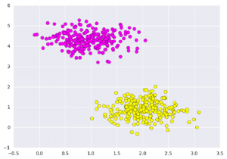 What Support vector machines do, is to not only draw a line between two classes here, but consider a region about the line of some given width. Here’s an example of what it can look like:

# creating linspace between -1 to 3.5
xfit = np.linspace(-1, 3.5)

# plotting scatter
plt.scatter(X[:, 0], X[:, 1], c=Y, s=50, cmap='spring')

# plot a line between the different sets of data
for m, b, d in [(1, 0.65, 0.33), (0.5, 1.6, 0.55), (-0.2, 2.9, 0.2)]:
yfit = m * xfit + b
plt.plot(xfit, yfit, '-k')
plt.fill_between(xfit, yfit - d, yfit + d, edgecolor='none',
color='#AAAAAA', alpha=0.4)

plt.xlim(-1, 3.5);
plt.show()

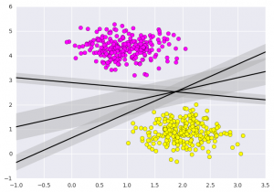
Importing datasets
This is the intuition of support vector machines, which optimize a linear discriminant model representing the perpendicular distance between the datasets. Now let’s train the classifier using our training data. Before training, we need to import cancer datasets as csv file where we will train two features out of all features.

# importing required libraries
import numpy as np
import pandas as pd
import matplotlib.pyplot as plt

# reading csv file and extracting class column to y.
x = pd.read_csv("C:\...\cancer.csv")
a = np.array(x)
y = a[:,30] # classes having 0 and 1

# extracting two features
x = np.column_stack((x.malignant,x.benign))

# 569 samples and 2 features
x.shape

print (x),(y)

[[ 122.8 1001. ]
[ 132.9 1326. ]
[ 130. 1203. ]
...,
[ 108.3 858.1 ]
[ 140.1 1265. ]
[ 47.92 181. ]]

array([ 0., 0., 0., 0., 0., 0., 0., 0., 0., 0., 0., 0., 0.,
0., 0., 0., 0., 0., 0., 1., 1., 1., 0., 0., 0., 0.,
0., 0., 0., 0., 0., 0., 0., 0., 0., 0., 0., 1., 0.,
0., 0., 0., 0., 0., 0., 0., 1., 0., 1., 1., 1., 1.,
1., 0., 0., 1., 0., 0., 1., 1., 1., 1., 0., 1., ....,
1.])
Fitting a Support Vector Machine
Now we’ll fit a Support Vector Machine Classifier to these points. While the mathematical details of the likelihood model are interesting, we’ll let read about those elsewhere. Instead, we’ll just treat the scikit-learn algorithm as a black box which accomplishes the above task.

# import support vector classifier
# "Support Vector Classifier"
from sklearn.svm import SVC
clf = SVC(kernel='linear')

# fitting x samples and y classes
clf.fit(x, y)

After being fitted, the model can then be used to predict new values:

clf.predict([[120, 990]])

clf.predict([[85, 550]])

array([ 0.])
array([ 1.])
Let’s have a look on the graph how does this show. 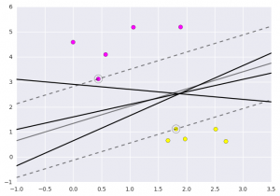 This is obtained by analyzing the data taken and pre-processing methods to make optimal hyperplanes using matplotlib function. This article is contributed by Afzal Ansari. If you like GeeksforGeeks and would like to contribute, you can also write an article using write.geeksforgeeks.org or mail your article to review-team@geeksforgeeks.org. See your article appearing on the GeeksforGeeks main page and help other Geeks. Please write comments if you find anything incorrect, or you want to share more information about the topic discussed above.

SVM Hyperparameter Tuning using GridSearchCV | ML
A Machine Learning model is defined as a mathematical model with a number of parameters that need to be learned from the data. However, there are some parameters, known as Hyperparameters and those cannot be directly learned. They are commonly chosen by humans based on some intuition or hit and trial before the actual training begins. These parameters exhibit their importance by improving the performance of the model such as its complexity or its learning rate. Models can have many hyper-parameters and finding the best combination of parameters can be treated as a search problem.
SVM also has some hyper-parameters (like what C or gamma values to use) and finding optimal hyper-parameter is a very hard task to solve. But it can be found by just trying all combinations and see what parameters work best. The main idea behind it is to create a grid of hyper-parameters and just try all of their combinations (hence, this method is called Gridsearch, But don’t worry! we don’t have to do it manually because Scikit-learn has this functionality built-in with GridSearchCV.
GridSearchCV takes a dictionary that describes the parameters that could be tried on a model to train it. The grid of parameters is defined as a dictionary, where the keys are the parameters and the values are the settings to be tested.
This article demonstrates how to use the GridSearchCV searching method to find optimal hyper-parameters and hence improve the accuracy/prediction results

Import necessary libraries and get the Data:
We’ll use the built-in breast cancer dataset from Scikit Learn. We can get with the load function:

import pandas as pd
import numpy as np
from sklearn.metrics import classification_report, confusion_matrix
from sklearn.datasets import load_breast_cancer
from sklearn.svm import SVC

cancer = load_breast_cancer()

# The data set is presented in a dictionary form:
print(cancer.keys())

dict_keys(['data', 'target', 'target_names', 'DESCR', 'feature_names', 'filename'])
Now we will extract all features into the new data frame and our target features into separate data frames.

df_feat = pd.DataFrame(cancer['data'],
columns = cancer['feature_names'])

# cancer column is our target
df_target = pd.DataFrame(cancer['target'],
columns =['Cancer'])

print("Feature Variables: ")
print(df_feat.info())

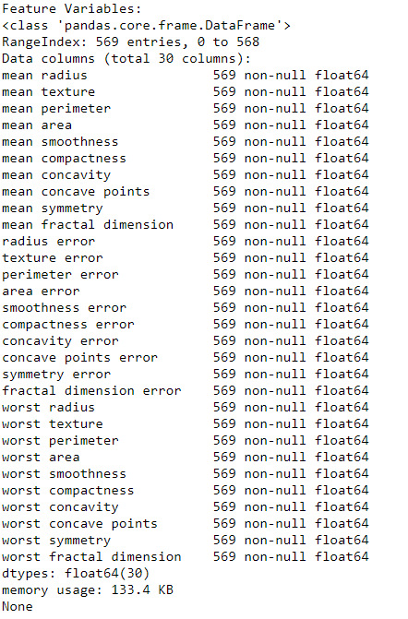

print("Dataframe looks like : ")
print(df_feat.head())

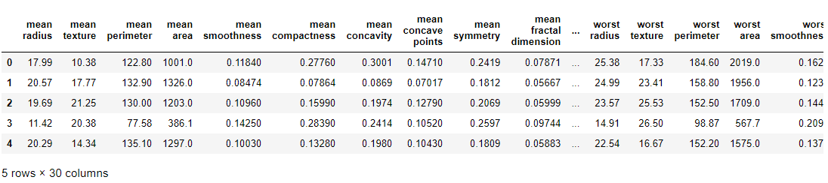

Train Test Split
Now we will split our data into train and test set with a 70: 30 ratio

from sklearn.model_selection import train_test_split

X_train, X_test, y_train, y_test = train_test_split(
df_feat, np.ravel(df_target),
test_size = 0.30, random_state = 101)

Train the Support Vector Classifier without Hyper-parameter Tuning –
First, we will train our model by calling the standard SVC() function without doing Hyperparameter Tuning and see its classification and confusion matrix.

# train the model on train set
model = SVC()
model.fit(X_train, y_train)

# print prediction results
predictions = model.predict(X_test)
print(classification_report(y_test, predictions))

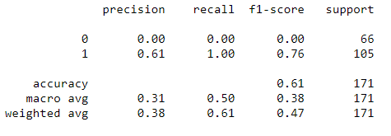
We got 61 % accuracy but did you notice something strange?
Notice that recall and precision for class 0 are always 0. It means that the classifier is always classifying everything into a single class i.e class 1! This means our model needs to have its parameters tuned.
Here is when the usefulness of GridSearch comes into the picture. We can search for parameters using GridSearch!

Use GridsearchCV
One of the great things about GridSearchCV is that it is a meta-estimator. It takes an estimator like SVC and creates a new estimator, that behaves exactly the same – in this case, like a classifier. You should add refit=True and choose verbose to whatever number you want, the higher the number, the more verbose (verbose just means the text output describing the process).

from sklearn.model_selection import GridSearchCV

# defining parameter range
param_grid = {'C': [0.1, 1, 10, 100, 1000],
'gamma': [1, 0.1, 0.01, 0.001, 0.0001],
'kernel': ['rbf']}

grid = GridSearchCV(SVC(), param_grid, refit = True, verbose = 3)

# fitting the model for grid search
grid.fit(X_train, y_train)

What fit does is a bit more involved than usual. First, it runs the same loop with cross-validation, to find the best parameter combination. Once it has the best combination, it runs fit again on all data passed to fit (without cross-validation), to build a single new model using the best parameter setting.
You can inspect the best parameters found by GridSearchCV in the best_params_ attribute, and the best estimator in the best_estimator_ attribute:

# print best parameter after tuning
print(grid.best_params_)

# print how our model looks after hyper-parameter tuning
print(grid.best_estimator_)

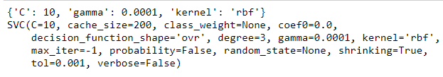
Then you can re-run predictions and see a classification report on this grid object just like you would with a normal model.

grid_predictions = grid.predict(X_test)

# print classification report
print(classification_report(y_test, grid_predictions))

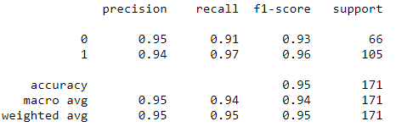
We have got almost 95 % prediction result.

Classifying data using Support Vector Machines(SVMs) in R
In machine learning, Support vector machines (SVM) are supervised learning models with associated learning algorithms that analyze data used for classification and regression analysis. It is mostly used in classification problems. In this algorithm, each data item is plotted as a point in n-dimensional space (where n is a number of features), with the value of each feature being the value of a particular coordinate. Then, classification is performed by finding the hyper-plane that best differentiates the two classes.
In addition to performing linear classification, SVMs can efficiently perform a non-linear classification, implicitly mapping their inputs into high-dimensional feature spaces.

How SVM works
A Support Vector Machine (SVM) is a discriminative classifier formally defined by a separating hyperplane. In other words, given labeled training data (supervised learning), the algorithm outputs an optimal hyperplane that categorizes new examples.
The most important question that arises while using SVM is how to decide the right hyperplane. Consider the following scenarios:
- Scenario 1:
In this scenario, there are three hyperplanes called A, B, C. Now the problem is to identify the right hyper-plane which best differentiates the stars and the circles.
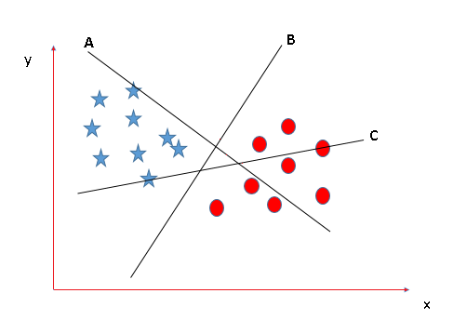
- The thumb rule to be known, before finding the right hyperplane, to classify star and circle is that the hyperplane should be selected which segregate two classes better.
In this case, B classifies star and circle better, hence it is a right hyperplane.
- Scenario 2:
Now take another Scenario where all three planes are segregating classes well. Now the question arises of how to identify the right plane in this situation.
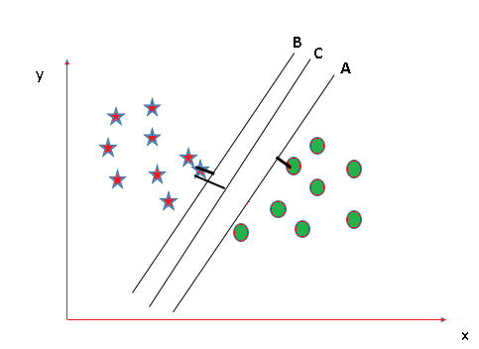
- In such scenarios, calculate the margin which is the distance between the nearest data point and hyper-plane. The plane has the maximum distance will be considered as the right hyperplane to classify the classes better.
Here C is having the maximum margin and hence it will be considered as a right hyperplane.
Above are some scenarios to identify the right hyper-plane.
Note: For details on Classifying using SVM in Python, refer to Classifying data using Support Vector Machines(SVMs) in Python

Implementation of SVM in R
Here, an example is taken by importing a dataset of Social network aids from file Social.csv
The implementation is explained in the following steps:
- Importing the dataset

# Importing the dataset
dataset = read.csv('Social_Network_Ads.csv')
dataset = dataset[3:5]

- Output:
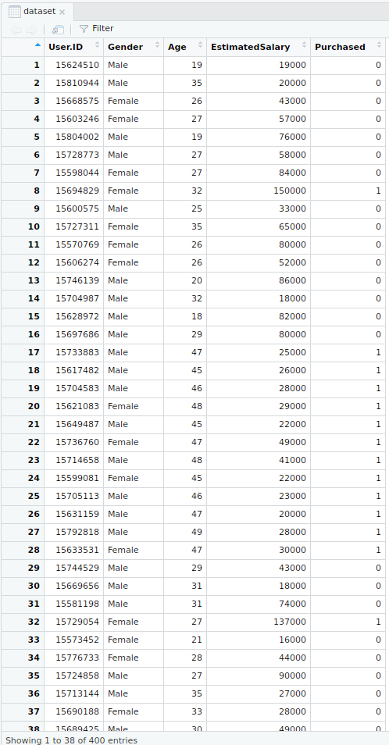

- Selecting columns 3-5
This is done for ease of computation and implementation (to keep the example simple).

# Taking columns 3-5
dataset = dataset[3:5]

- Output:
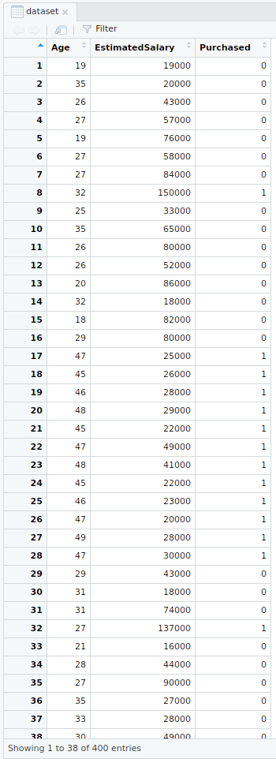

- Encoding the target feature

# Encoding the target feature as factor
dataset$Purchased = factor(dataset$Purchased, levels = c(0, 1))

- Output:
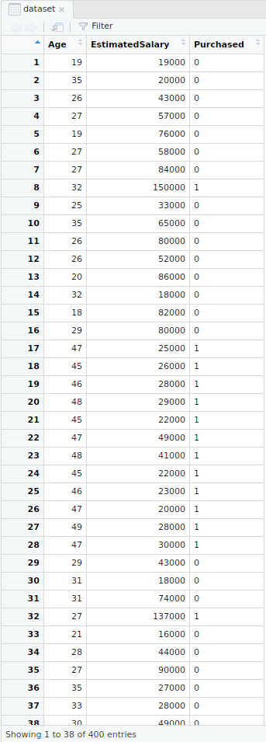

- Splitting the dataset

# Splitting the dataset into the Training set and Test set
install.packages('caTools')
library(caTools)

set.seed(123)
split = sample.split(dataset$Purchased, SplitRatio = 0.75)

training_set = subset(dataset, split == TRUE)
test_set = subset(dataset, split == FALSE)

- Output:
  - Splitter
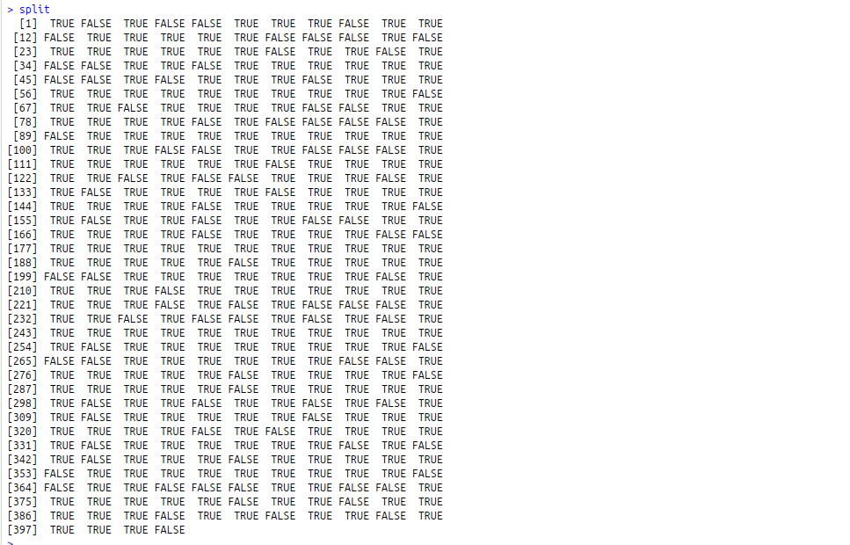

- Training dataset
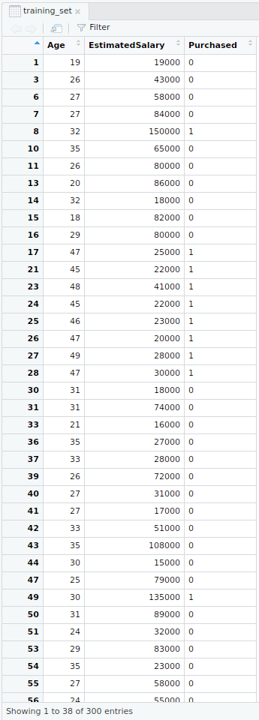

- Test dataset
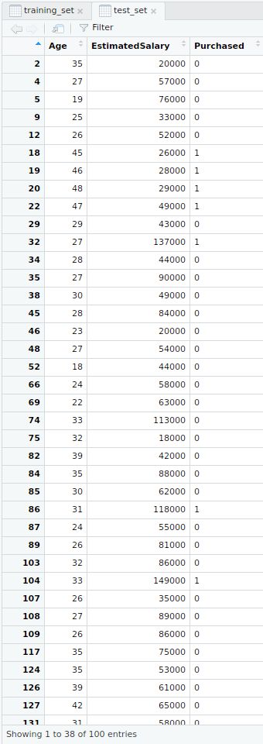

- Feature Scaling

# Feature Scaling
training_set[-3] = scale(training_set[-3])
test_set[-3] = scale(test_set[-3])

- Output:
  - Feature scaled training dataset
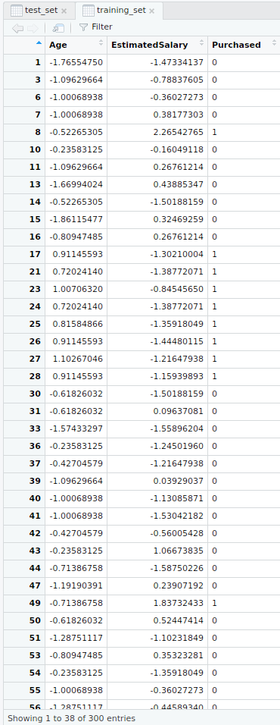

- Feature scaled test dataset
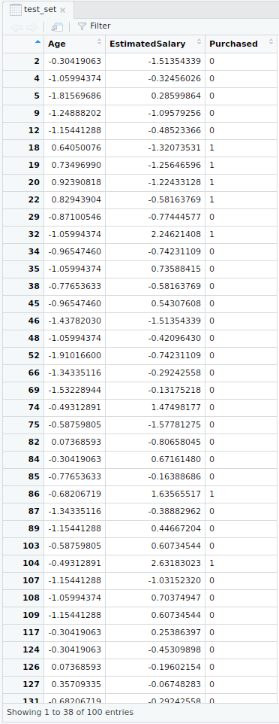

- Fitting SVM to the training set

# Fitting SVM to the Training set
install.packages('e1071')
library(e1071)

classifier = svm(formula = Purchased ~ .,
data = training_set,
type = 'C-classification',
kernel = 'linear')

- Output:
  - Classifier detailed
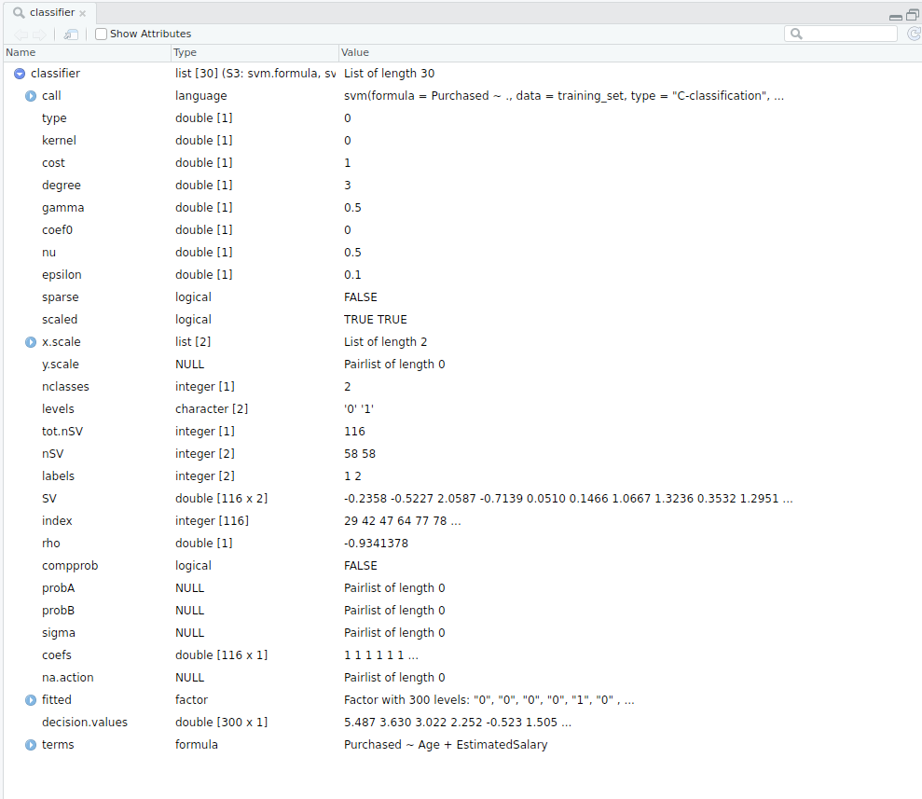

- Classifier in nutshell
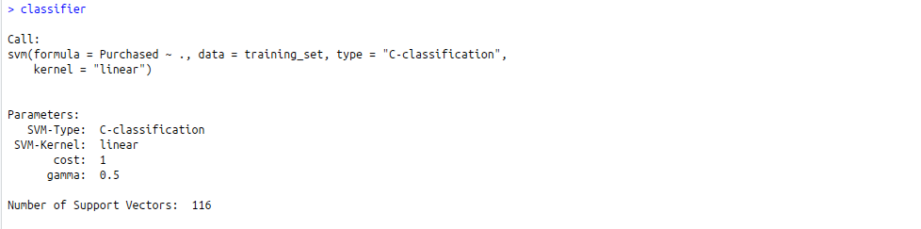

- Predicting the test set result

# Predicting the Test set results
y_pred = predict(classifier, newdata = test_set[-3])

- Output:
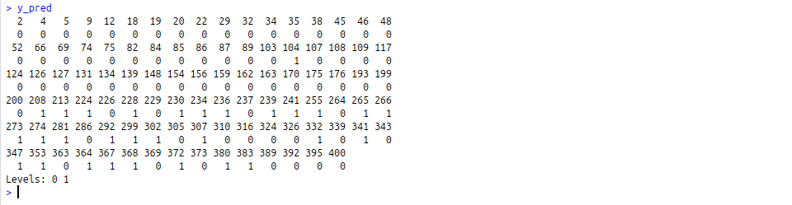

- Making Confusion Matrix

# Making the Confusion Matrix
cm = table(test_set[, 3], y_pred)

- Output:

- Visualizing the Training set results

# installing library ElemStatLearn
library(ElemStatLearn)

# Plotting the training data set results
set = training_set
X1 = seq(min(set[, 1]) - 1, max(set[, 1]) + 1, by = 0.01)
X2 = seq(min(set[, 2]) - 1, max(set[, 2]) + 1, by = 0.01)

grid_set = expand.grid(X1, X2)
colnames(grid_set) = c('Age', 'EstimatedSalary')
y_grid = predict(classifier, newdata = grid_set)

plot(set[, -3],
main = 'SVM (Training set)',
xlab = 'Age', ylab = 'Estimated Salary',
xlim = range(X1), ylim = range(X2))

contour(X1, X2, matrix(as.numeric(y_grid), length(X1), length(X2)), add = TRUE)

points(grid_set, pch = '.', col = ifelse(y_grid == 1, 'coral1', 'aquamarine'))

points(set, pch = 21, bg = ifelse(set[, 3] == 1, 'green4', 'red3'))

- Output:
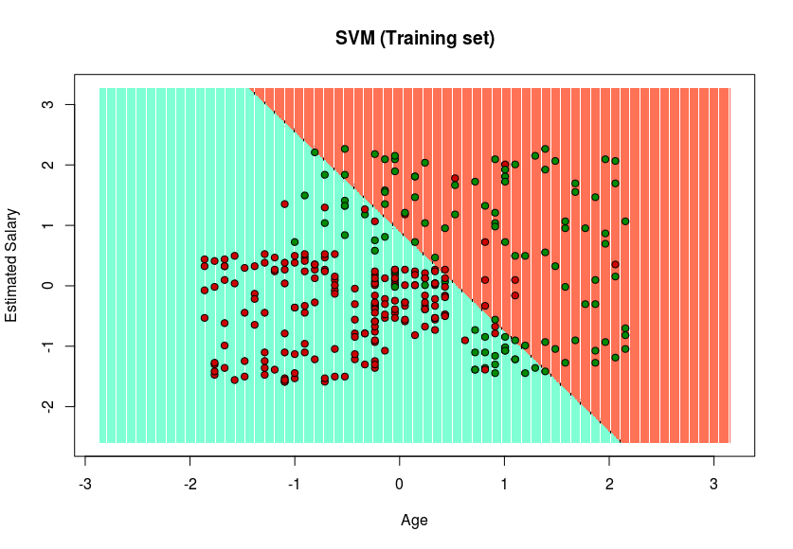

- Visualizing the Test set results

set = test_set
X1 = seq(min(set[, 1]) - 1, max(set[, 1]) + 1, by = 0.01)
X2 = seq(min(set[, 2]) - 1, max(set[, 2]) + 1, by = 0.01)

grid_set = expand.grid(X1, X2)
colnames(grid_set) = c('Age', 'EstimatedSalary')
y_grid = predict(classifier, newdata = grid_set)

plot(set[, -3], main = 'SVM (Test set)',
xlab = 'Age', ylab = 'Estimated Salary',
xlim = range(X1), ylim = range(X2))

contour(X1, X2, matrix(as.numeric(y_grid), length(X1), length(X2)), add = TRUE)

points(grid_set, pch = '.', col = ifelse(y_grid == 1, 'coral1', 'aquamarine'))

points(set, pch = 21, bg = ifelse(set[, 3] == 1, 'green4', 'red3'))

- Output:
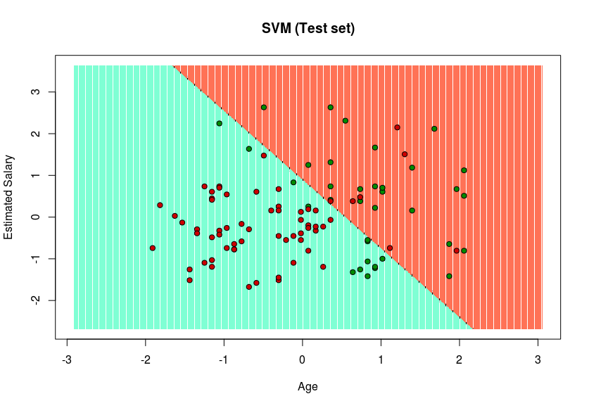

Since in the result, a hyper-plane has been found in the Training set result and verified to be the best one in the Test set result. Hence, SVM has been successfully implemented in R.

ML | Using SVM to perform classification on a non-linear dataset
Prerequisite: Support Vector Machines

Definition of a hyperplane and SVM classifier:
For a linearly separable dataset having n features (thereby needing n dimensions for representation), a hyperplane is basically an (n – 1) dimensional subspace used for separating the dataset into two sets, each set containing data points belonging to a different class. For example, for a dataset having two features X and Y (therefore lying in a 2-dimensional space), the separating hyperplane is a line (a 1-dimensional subspace). Similarly, for a dataset having 3-dimensions, we have a 2-dimensional separating hyperplane, and so on.
In machine learning, Support Vector Machine (SVM) is a non-probabilistic, linear, binary classifier used for classifying data by learning a hyperplane separating the data.
Classifying a non-linearly separable dataset using a SVM – a linear classifier:
As mentioned above SVM is a linear classifier which learns an (n – 1)-dimensional classifier for classification of data into two classes. However, it can be used for classifying a non-linear dataset. This can be done by projecting the dataset into a higher dimension in which it is linearly separable!
To get a better understanding, let’s consider circles dataset.
# importing libraries
import numpy as np
import matplotlib.pyplot as plt
from sklearn.datasets import make_circles
from mpl_toolkits.mplot3d import Axes3D

# generating data
X, Y = make_circles(n_samples = 500, noise = 0.02)

# visualizing data
plt.scatter(X[:, 0], X[:, 1], c = Y, marker = '.')
plt.show()

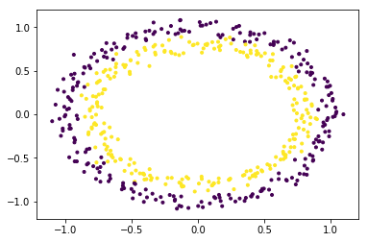
The dataset is clearly a non-linear dataset and consists of two features (say, X and Y).
In order to use SVM for classifying this data, introduce another feature Z = X2 + Y2 into the dataset. Thus, projecting the 2-dimensional data into 3-dimensional space. The first dimension representing the feature X, second representing Y and third representing Z (which, mathematically, is equal to the radius of the circle of which the point (x, y) is a part of). Now, clearly, for the data shown above, the ‘yellow’ data points belong to a circle of smaller radius and the ‘purple’ data points belong to a circle of larger radius. Thus, the data becomes linearly separable along the Z-axis.
# adding a new dimension to X
X1 = X[:, 0].reshape((-1, 1))
X2 = X[:, 1].reshape((-1, 1))
X3 = (X1**2 + X2**2)
X = np.hstack((X, X3))

# visualizing data in higher dimension
fig = plt.figure()
axes = fig.add_subplot(111, projection = '3d')
axes.scatter(X1, X2, X1**2 + X2**2, c = Y, depthshade = True)
plt.show()

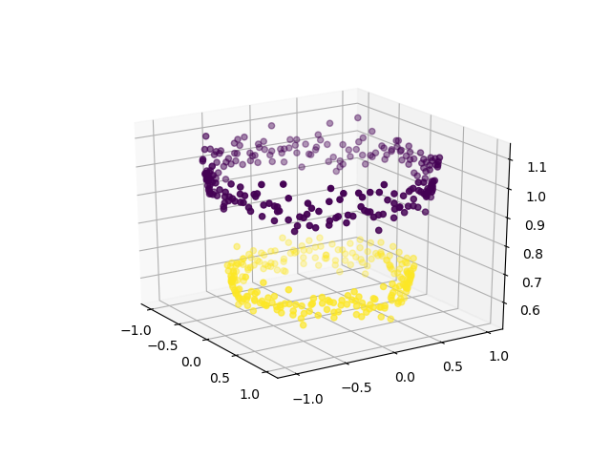
Now, we can use SVM (or, for that matter, any other linear classifier) to learn a 2-dimensional separating hyperplane. This is how the hyperplane would look like:
# create support vector classifier using a linear kernel
from sklearn import svm

svc = svm.SVC(kernel = 'linear')
svc.fit(X, Y)
w = svc.coef_
b = svc.intercept_

# plotting the separating hyperplane
x1 = X[:, 0].reshape((-1, 1))
x2 = X[:, 1].reshape((-1, 1))
x1, x2 = np.meshgrid(x1, x2)
x3 = -(w[0][0]*x1 + w[0][1]*x2 + b) / w[0][2]

fig = plt.figure()
axes2 = fig.add_subplot(111, projection = '3d')
axes2.scatter(X1, X2, X1**2 + X2**2, c = Y, depthshade = True)
axes1 = fig.gca(projection = '3d')
axes1.plot_surface(x1, x2, x3, alpha = 0.01)
plt.show()

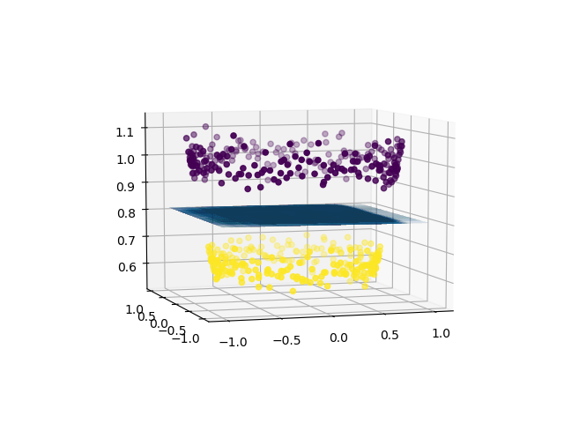
Thus, using a linear classifier we can separate a non-linearly separable dataset.
A brief introduction to kernels in machine learning:
In machine learning, a trick known as “kernel trick” is used to learn a linear classifier to classify a non-linear dataset. It transforms the linearly inseparable data into a linearly separable one by projecting it into a higher dimension. A kernel function is applied on each data instance to map the original non-linear data points into some higher dimensional space in which they become linearly separable.

